The instruction of creating online lectures on Google Meet platform

- Log into your Gmail account.
- Click the „9 dots” icon in the upper right corner and select „Calendar” from the list.

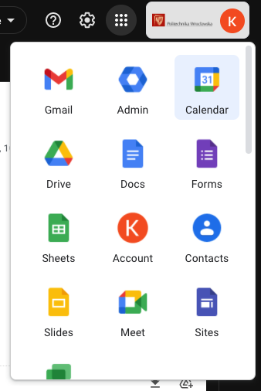

- The Calendar will open in a new tab of your browser. Choose „Create” or click on any free place in the Calendar.

- The event edition tab will open where you should specify the main information about the event:
  - Add title – e.g. Trial lecture,
  - Date – day and time of the lecture, here you can define the periodicity of the event, e.g. 16th of September, 10am – 12am,
  - Add guests – type email addresses of the participants or define the group in your contact list and choose it from the list,
  - Add a video call on Google Meet – generate the link for your meeting,
  - Add rooms or location – type the place by hand,
  - Add attachments or description – type the content of your description or add an attachment to the message, which can be sent to the participants together with your invitation,
  - More options – opens the event edition tab in a full window,
  - Save – save changes.
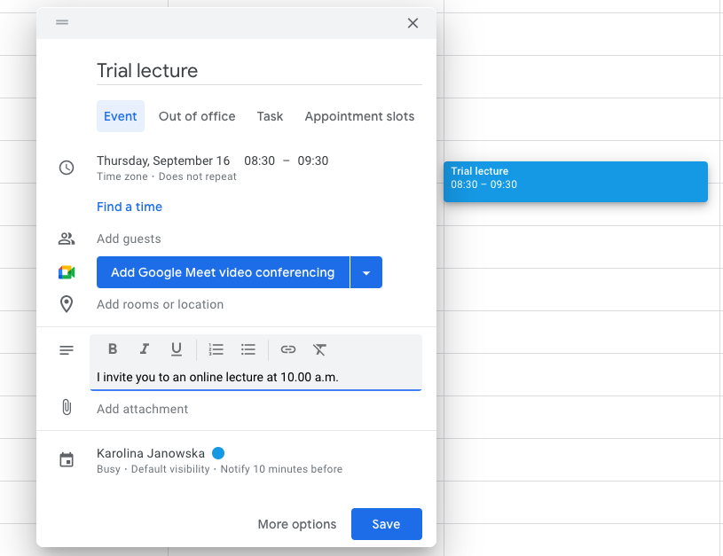

- After saving the event, a tab will show up asking if you would like to send update emails to existing Google Calendar guests. Depending on your preferences, you can choose:
  - Cancel – go back to editing your event,
  - Don’t send – the invitation will not be sent by e-mail, the event will only be added to the participants' calendar,
  - Send – send an invitation to the participants.
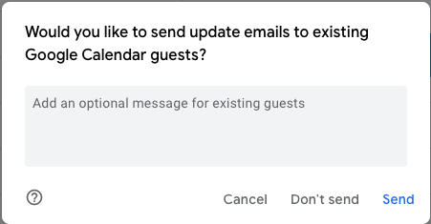
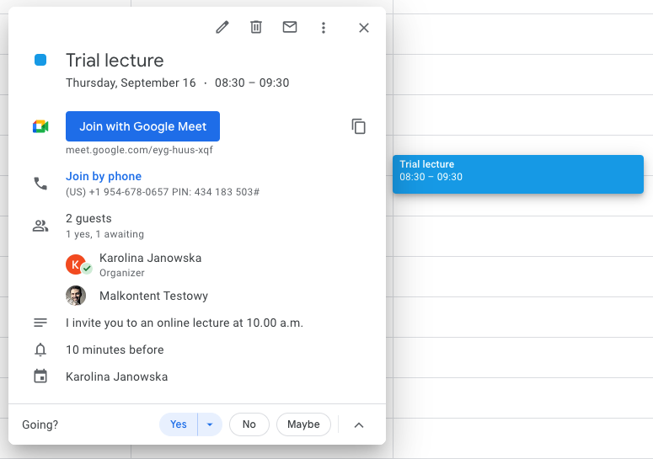

- In order to join an online event, select the event from the calendar and then click "Join with Google Meet".

Attention: from the window above you can:
- Edit an event,
- Cancel it,
- Send a message to the paricipants again,
- More options: duplicate the event, delegate hosting of the event, etc.

- The "waiting room" will open in a new tab of your browser, in which you can check the availability of the camera and microphone and join the meeting with Google Meet.
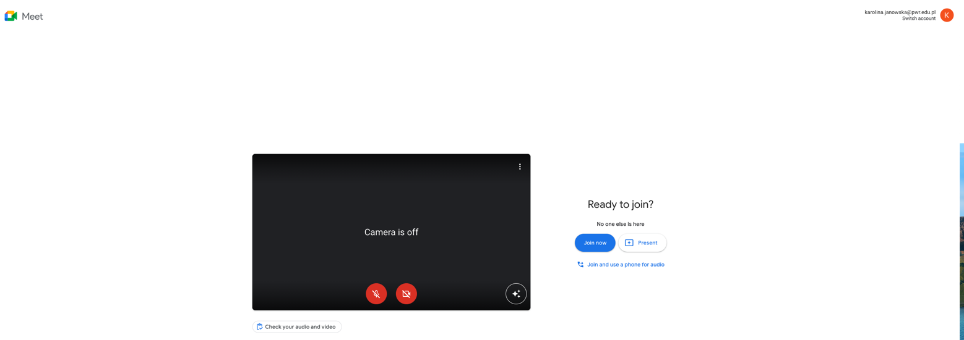
In the lower left corner of the black screen, you can adjust the background.

- A chat window appears. On the bottom bar on the left:
  - Time and name of the event
  - Microphone
  - Camera
  - Rise a hand/put your hand down – the equivalent of raising a hand in class,
  - Present now:
    - The whole screen – share everything,
    - A window – share only a chosen file, e.g. presentation (that needs to be opened earlier),
    - A tab – share a tab of your browser.
  - More options:
    - Board – you can use Jamboard,
    - Change layout - change the layout of the tiles,
    - Full screen - full screen view of the meeting,
    - Change background,
    - Subtitles,
    - Report a problem/Report abuse,
    - Help,
    - Settings – if you use a different microphone or screen, you can select it in the settings.
  - Leave the meeting,
  - Meeting details – in addition to information about this event, the attachment placed in the event description will also appear here,
  - Participants – the list of participants of the event. The event host can moderate the meeting, e.g. mute the microphones, block the chat, disable participant’s presentation, etc.
  - Chat,
  - Actions – turning on the virtual board,
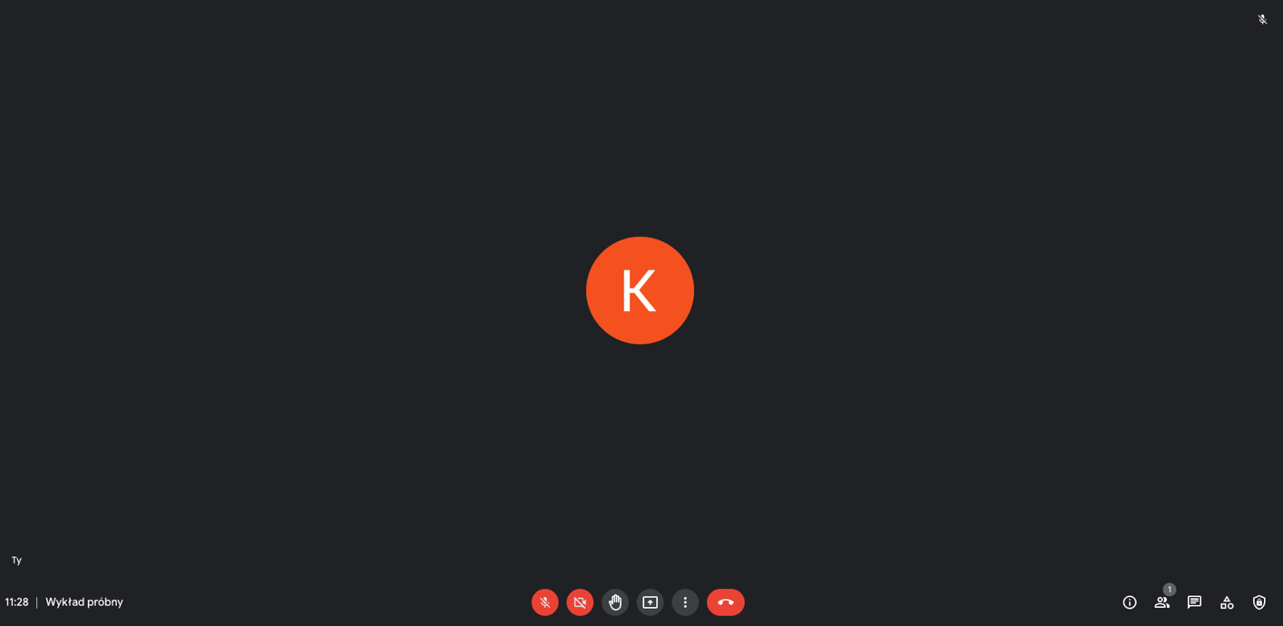
  - Host settings.
b c d e f g h i j k l
a

